VISITOR MANAGEMENT SYSTEM USING
SERVICENOW

Milestone 2: Data Model Design
Objective
Design and implement the database structure for the Visitor Management System by creating custom tables, defining fields, and establishing relationships between employees and visitors.
Step 1: Create Employee Details Table
Navigation:
Studio → Create Application File → Table
Table:
Employee Details
Fields:
- Employee ID
- Employee Name
- Email
- Phone Number
- Department
- Designation
- Location
- Status
Purpose
The Employee table stores information about employees who can act as hosts for visitors.

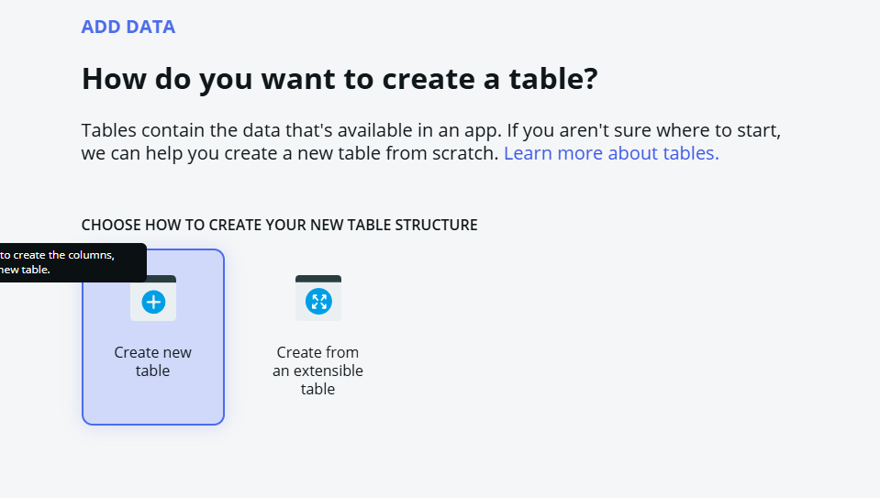

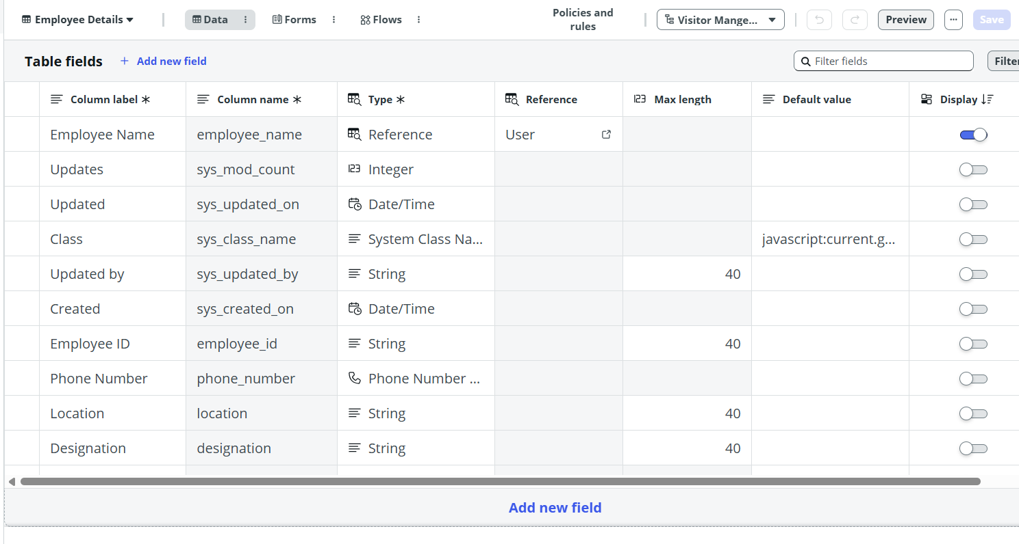

Step 2: Create Visitor Details Table
Create another custom table.
Fields:
- Visitor Name
- Phone Number
- Email
- Company Name
- Visit Date (Date/Time)
- Employee Host
- Purpose of Visit
- Status
- Check In Time
- Check Out Time

Purpose
The Visitor table stores visitor details, visit schedules, approval status, and check-in/check-out information.

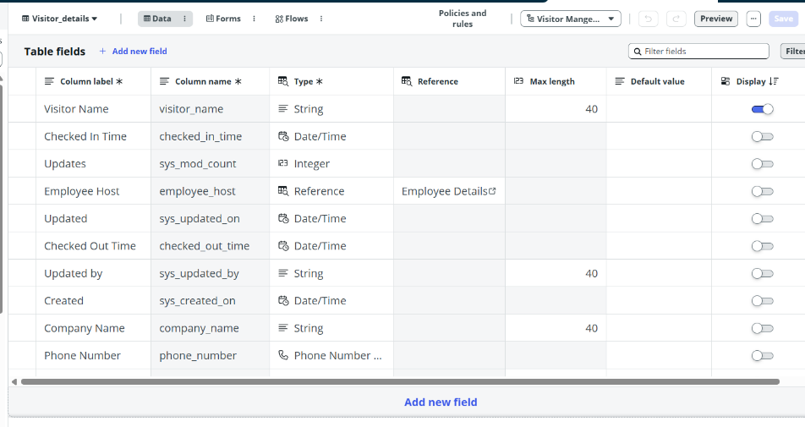

Step 3: Create Reference Relationship
Reference Field
Employee Host
Reference Table
Employee
Relationship
One Employee → Many Visitors
Purpose
This relationship associates each visitor request with an employee host and enables administrators to track visitors assigned to a specific employee.

Step 4: Create Application Modules
Navigation
All → Application Menus & Modules
Modules Created
- Visitors
- Create Visitor Request
- Employees
- Host Visitor Requests
Purpose
The application modules provide easy navigation to different functionalities of the Visitor Management System.
- Visitors – Displays all visitor records available in the system.
- Create Visitor Request – Allows users to submit a new visitor request.
- Employees – Displays employee records that act as visitor hosts.
- Host Visitor Requests – Allows users to view and track their submitted visitor requests.
Deliverable
Application modules were successfully created and configured to improve accessibility and navigation within the Visitor Management System.
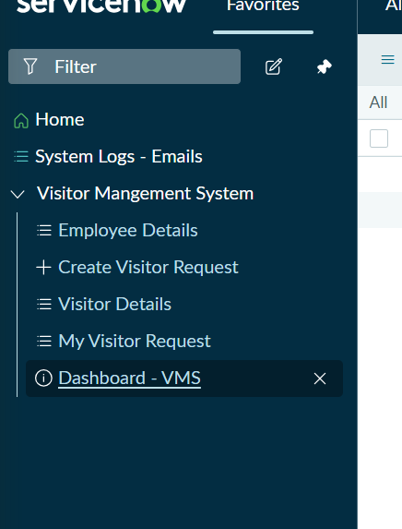

Learning Outcomes
• Created custom tables.
• Extended Task table.
• Created relationships.
• Built navigation modules.

